**Sinister Transistor**

**Detailed Design**

**COP 4331, Spring 2016**

Team Name: The Mega Bytes

Team Members:

* Greg Kelso
* Mark Boutwell
* Joel Gardyasz

Modification history:

|  |  |  |  |
| --- | --- | --- | --- |
| Version | Date | Who | Comment |
| v0.0 | 03/02/16 | Greg | Template |
| V0.2 | 03/03/16 | Greg, Mark | Added sequence diagram |
| V0.5 | 03/04/16 | Mark | Added class diagram |
| V1.0 | 03/04/16 | Greg | Completed Design issues and Trace of Requirements |

**Contents of this Document**

Design Issues

Detailed Design Information

Trace of Requirements to Design

Design Issues

<In this section, provide more detail to the design issues discussed in the high-level design. Document the results of each design prototype. Document design decisions and associated risks. Provide sufficient detail so the maintainer won't have to say "why did they do it this way?">

We have chosen to go with an object-oriented design, because it helps with reusability and encapsulation. It makes testing easy, because we can easily create as many or as few NPCs as we would like. Once the architecture is set up, prototyping becomes extremely easy and quick. Proper class structures and inheritance allow for us to have multiple types of NPCs; simple enemies, helpful quest guides, and even bosses.

We chose a Model-View-Controller (MVC) architecture, because it is the best way for us to quickly implement an object-oriented software design. By separating the models from the controllers, we are able to instantiate as many instances of different objects as we would like. The object-oriented MVC design also allows us to easily make programming changes, since most of the interactions between classes and inherited methods do most of the legwork when it comes to running the models. Separating these from the View also makes testing much simpler; depending on the bug or issue, we can then logically follow the path of which part of the system was most likely broken. Ruling out the Controller for a particular bug will save 33% of troubleshooting, and the object-oriented design only further enhances the ease of troubleshooting.

We will be creating the game in 2D, which limits the graphics and processing requirements expected of the user. However, we will make the Unity recommended computer specifications easily readable for the user, so they can quickly see if their system will run the game or not. In addition to this, we do not plan on including complex graphics, animations, or large environments, in order to ensure we don’t push the capabilities of a user’s system, and ensure that the user has a smooth framerate for the game.

We are designing the game for OS X, Windows, and Linux environments. Porting to other environments is doable, however we feel that these operating systems will reach the most users, and also make demonstration of the game easy to accomplish.

We are purposefully not storing any data from the user, nor requiring the user to download anything other than the single executable file for the game. This ensures that the user will not have to worry about possible information leaks or computer viruses while playing the game. It also simplifies work on the developer end, allowing the team to have more time to put into the quality of the game.

Detailed Design Information

**Class Diagram**

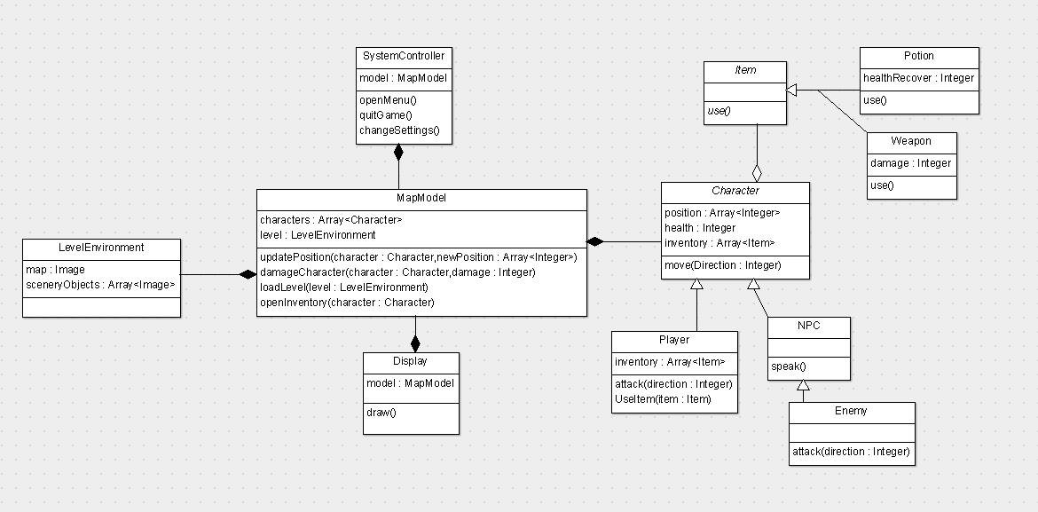

**Sequence Diagram**



Trace of Requirements to Design:

|  |  |
| --- | --- |
| **Requirement** | **Trace** |
| The player shall be able to move up, down, left, and right, unless stopped by a wall. | Using User Input, the user sends input to the Character Controller which interacts with the Map Model. |
| The software shall feature music and sound effects. | Music will be stored in the System Controller and modified with User Input. |
| The player shall be able to navigate into other areas and rooms in their environment. These rooms shall load and open once the player has indicated their desire to enter. | The Map Model will manage the current status of the rooms, and send the appropriate data to the Display interface. |
| The player and enemies shall have a set amount of health. If this is depleted, the player/enemy shall die. If the player dies the game shall end. | Each entity controller will be responsible for storing the data of its individual health, and the Map Model will remove an NPC or end the game if an entities’ health is depleted. |
| The user shall be able to start a new game. | New games are handled with the System Controller. |
| The player shall be able to pause the current game to pull up a pause menu. | Pausing of the game is handled with the System Controller. |
| The application shall run on a PC using the latest version of either Windows, OSX, or Linux | The Unity System Requirements outlined in Section 42 of the Software Requirements Specification outlines the recommended settings for the user’s computer; if those are met, the game will run. This information will be sent to the user with the Display interface. |
| The application should support keyboard and mouse input | The User Input interface will collect and send keyboard and mouse input data. |
| The game shall support users of all skill levels and of all ages. | The game will feature modifiable difficulty levels, accessed with the System Controller. |
| The game shall accommodate all players by having an ability to increase or decrease audio and font size. | These features will be accessed and modified with the System Controller. |
| The software should be bug free. The game should not let users exploit bugs to cheat and achieve a higher score. | The object-oriented design will allow for easy programming and allow the game to remain bug-free for the user. |
| The player shall be able view a manual consisting of game features and mechanics. | The game manual will be stored with the System Controller and displayed with the Display interface. |
| All game documentation shall be put online for the users to explore all aspects of the game and its design and implementation. | All design documentation will be stored online on the private Github repository. Any user is able to view the repository, except only developers can modify it. |
| Entity Controllers shall store all relevant data to the object it is attached to. | The Character Controller and NPC Controller stores data relevant to each instance, and sends the data to the Map Model to make changes to the game world. |
| Unity built-in functions shall be used when relevant. | To ensure object-oriented principles are used, the developers will use built-in functions to minimize the amount of unnecessary code written. |
| The system shall require no more than three software engineers to complete the project. | The project will be scaled to a level that is achievable for three software engineers to complete. |
| The project shall be completed with Unity2D, coded in C#, and managed with Git version control. | All development requirements of the game are met, and are the ideal tools for creating an object-oriented 2D Unity video game. |
| The project, along with its required documentation and presentation brief, shall be completed no later than 11 April 2016. | Developers will reassess the requirements and design of the game if the deadline makes completion unfeasible. |
| The project shall be completed with only free software engineering tools. | All of the requirements are capable of being completed with free software. |
| The overall size of the project, including necessary documentation, shall take no more than 1GB of memory. | By sticking to the current design and architecture, the 1GB size requirement will easily be met. |
| The system shall remain secure during development. | By storing the project on a private Github repository, the project will be secure. |
| The system shall be stored and version controlled using Git. | As long as developers do not use other forms of version control in addition to Git, then the project will be properly maintained. |
| The system shall execute as a standalone application for Windows, OS X, and Linux devices. | By keeping with Windows, OS X and Linux executables, the Display interface will not have to render different scenarios for different devices. |
| The system shall be readable to all speakers of the English language. | The game will be developed in English, and all documentation regarding the game will be in English. |
| The system shall minimize the required time to test. | By using a MVC object-oriented design, testing time is minimized. |
| The user shall meet the minimum Unity System Requirements in order to play the video game. | The System Controller will use the Display interface to inform the user of the Unity System Requirements. |